Atomic spectra Name__________________________

Question 1

An element, such as neon, is able to be identified by its unique emission spectrum.

1. Describe what is occurring within an atom when an emission spectrum is produced. (2)

Electrons are found in set energy levels. When an excited electron that has absorbed energy falls from a higher to a lower energy level, it releases the energy difference between the two energy levels. This is released in the form of a photon. This photon can be in the visible spectrum. Since the energy levels for any atom are defined, there are set energy differences between different energy levels. For example, the energy difference from the first and second energy level (n = 1 and n = 2) for hydrogen is equal to the energy of a red photon. All the possible visible light an electron can give off as it falls to a lower energy level make up an atom’s emission spectrum. Depending on the energy of the photon, the visible light will have a different colour.

1. Draw a relevant diagram to support your answer (4)

Question 2

1. The emission spectrum for hydrogen is below. Explain why hydrogen, an element that only has one electron can produce an emission spectra with 5 lines observable in the visible spectrum. (2)

…………………………………………………………………………………………………………………………………………………………………………………………………………………………………………………………………………………………………………………………………………………………………………………………………………………………………………………………………………………………………………………………………………………………………………………………………………………………………………………………………………………………………………………..

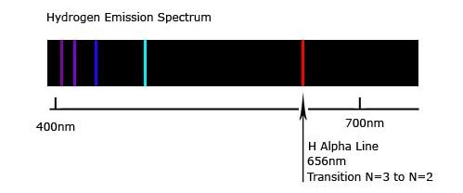

b) Compare and contrast the appearance of the absorption spectrum of hydrogen, compared to the emission spectrum of hydrogen shown above. (2)

……………………………………………………………………………………………………………………………………………………………………………………………………………………………………………………………………………………………………………………………………………………………………………………………………………………………………………………………………………………………………………………………………………………………………………………………………………………………………………………………………………

Question 3

A flame test is a simple laboratory test based on the same principle as AAS.

Describe two similarities and two differences between a flame test and AAS. (4)

|  |
| --- |
| **Similarities**  1.    2. |
| **Differences**  1.    2. |

Question 3

Describe two similarities and two differences between a flame test and AAS. (4 marks)

|  |  |
| --- | --- |
| **Description** | **Marks** |
| Similarities - any two   * detect metals * relies on unique quantum levels (of electrons) * uses a flame * wavelengths of light the same | 1-2 |
| Differences - any two  Flame test:   * uses emission spectrum (AAS uses absorption spectrum) * metal ions vaporised (in AAS substance is decomposed and atomised) * only identifies a metal (whereas AAS can determine concentration of the metal) * less accurate (as some metals have similar flame colours) | 1-2 |
| **Total** | 4 |